**Supplementary materials**

**Derivation of attack rate and handling time for *Gammarus***

Attack rate (i.e. the rate of encountering leaf discs per of unit of leaf mass) was estimated by assuming that the proportion of ingested leaf litter follows an exponential decay over time (Juliano et al. 2001). We first calculated the decay rate as *DC*T = –log (1 – *IR*T × *t* / *ML*), where *IR*T is the daily ingestion rate at a temperature *T* (mg C mg C-1 d-1) calculated using the experimental activation energy of ingestion rate in Eq. 1a, *t* is duration of the experiment (d) and *ML* is the mean initial C mass of leaf discs in microcosms (i.e. 10.25 mg C). Attack rate was then obtained by dividing the estimated decay rate by the experimental duration (*a*T = *DC*T / *t*). Handling time (i.e. the fraction of time dedicated to leaf discs manipulation and digestion) was calculated as the inverse of the ingestion rate (*h*T = 1 / *IR*T) because leaf litter biomass was not limiting in our experiment and *Gammarus* reached maximum ingestion rate (Sentis et al. 2013).

***Gammarus* body mass reduction scenarios**

*Gammarus* body size was changing with temperature as follows: *M* = *MR* × *c* × e*sT*, where *M* is the dry body mass changing with temperature (mg), *MR* is the dry body mass at a reference temperature of 12.5 °C (mg), *c* is the conversion factor of dry to wet mass (i.e. 6.5, Peters 1983), *s* quantifies the direction and magnitude of body mass change with temperature and *T* is the temperature (°C). Along with the TSRR scenario, we simulated 2 additional body size change scenarios based on the empirical results from a meta-analysis by Foster et al. (2012): (1) an “average aquatic TSR” scenario using the mean relationship between body mass and temperature for aquatic organisms (i.e. TSRA, *s* = –4.23) and (2) a “maximum aquatic TSR” scenario corresponding to the largest body size decrease with temperature reported in Forster et al. (2012) (i.e. TSRM, *s* = –8.0).

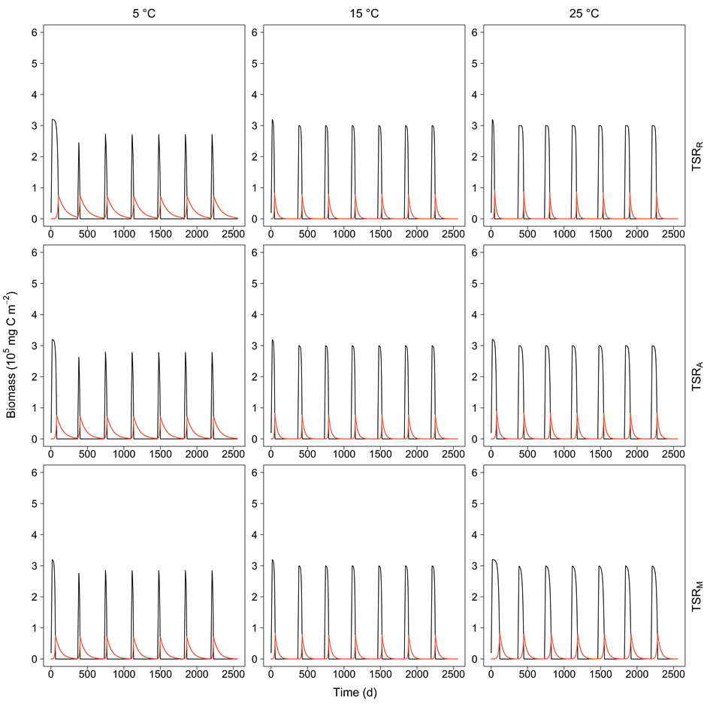**Figure S1:** Temporal dynamics of leaf litter (black line) and *Gammarus* (red line) biomasses over 7 years for 3 water temperature treatments (in columns) and 3 different temperature-size scenarios (in rows): the reference scenario (i.e. TSRR), the average TSR scenario (i.e. TSRA), and the strong TSR scenario (i.e. TSRM). Annual leaf litter inputs (3 × 105 mg C m–2) were simulated over the first 15 days of each year and initial biomass for *Gammarus* was set to 15 mg C m–2.

**Figure S2:** Mean annual number of days (a) for the entire year above the 20% threshold (6 × 104 mg C m-2) for leaf litter stock and (b) above the 5% threshold (5 × 103 mg C m-2) for *Gammarus* biomass. Mean numbers of days were estimated over 6 years as function of water temperature and using the average TSR scenario (i.e. TSRA) for crossed combinations of 3 different leaf litter stock inputs and initial *Gammarus* biomasses. Simulations included the reference litter stock (i.e. 300 000 mg C m–2 year-1, black line), the low litter stock (i.e. 100 000 mg C m–2 year-1, red line), or the high litter stock (i.e. 900 000 mg C m–2 year-1, blue line) and the reference *Gammarus* biomass (i.e. 15 mg C m–2, GC), the low *Gammarus* biomass (i.e. 5 mg C m–2, GR), or the high *Gammarus* biomass (i.e. 45 mg C m–2, GI). Dots represent the biomass values and lines were obtained by smoothing the curves linking the dots. Error bars (grey bars) correspond to standard deviations estimated for each temperature and temperature-size scenario over 6 years.

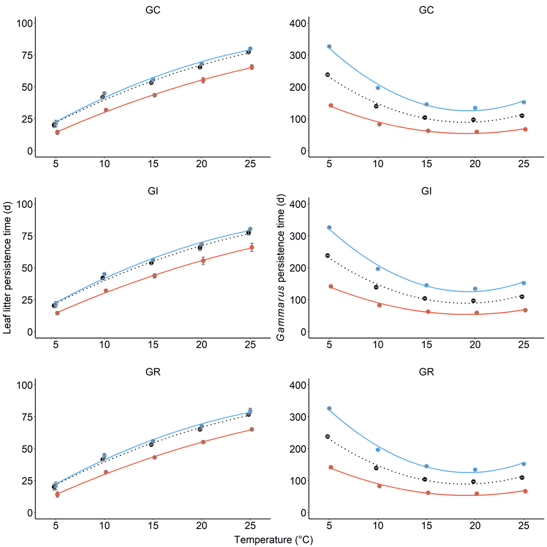

**(a)**

**(b)**

Figure S3: Mean slope of biomass decrease after maximum biomass peak (absolute value) of (a) leaf litter stock and (b) Gammarus stock with temperature-independent assimilation efficiency. Mean slopes were estimate over 6 consumer-resource cycles as a function of water temperature for the 3 different temperature-size scenarios: the reference scenario (i.e. TSRR, black dotted line), the average TSR scenario (i.e. TSRA, blue solid line), and the strong TSR scenario (i.e. TSRM, red solid line). Dots represent the slope values and lines were obtained by smoothing the curves linking the dots. Error bars (grey bars) correspond to standard deviations estimated for each temperature and temperature-size scenario over 6 years.

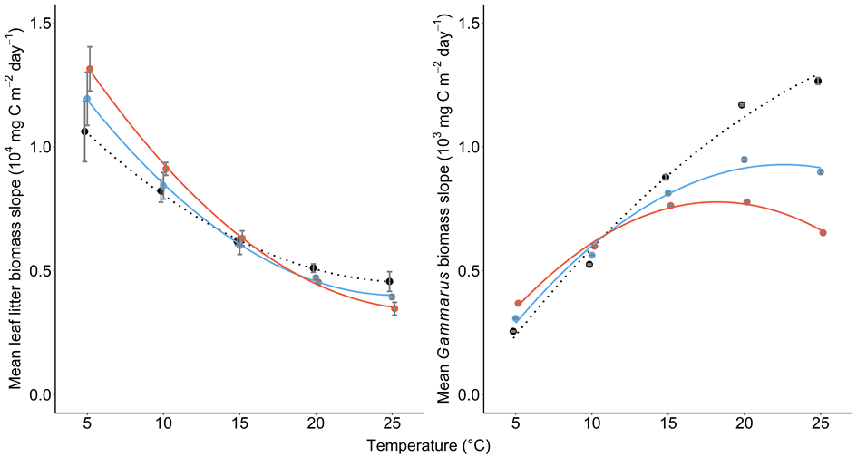

**(a)**

**(b)**

**Figure S4:** Mean annual number of days (a) above the 20% threshold (6 × 104 mg C m-2) for leaf litter stock and (b) above the 5% threshold (5 × 103 mg C m-2) for *Gammarus* stock with temperature-independent assimilation efficiency. Mean numbers of days were estimated over 6 years as a function of water temperature for the 3 different temperature-size scenarios: the reference scenario (i.e. TSRR, black dotted line), the average TSR scenario (i.e. TSRA, blue solid line), and the strong TSR scenario (i.e. TSRM, red solid line). Dots represent the biomass values and lines were obtained by smoothing the curves linking the dots. Error bars (grey bars) correspond to standard deviations estimated for each temperature and temperature-size scenario over 6 years.

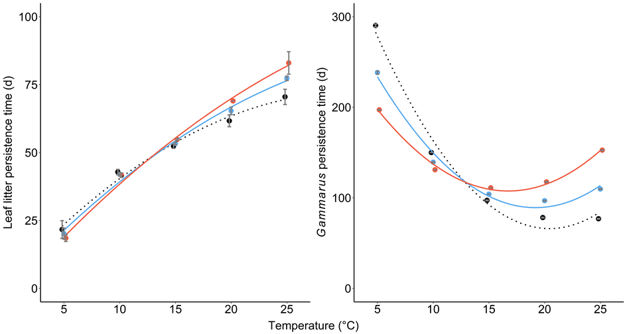

**(a)**

**(b)**